Name: Neha Deshmukh

Institute: A. P. Shah Institute of Technology, Thane

Application name: Plasma Donor App

GitHub link(personal): <https://github.com/nehatheone/PLASMA-APP.git>

GitHub link(collaborated with smartinterz):

Demo Video Link: <https://drive.google.com/file/d/1gu6V-uzDnFoLdrMfxQRAP-3BAdGQZNwS/view?usp=sharing>

Description:

Plasma donor app is created for users who needs issue plasma requests.

For which user needs to register in the app.

User supposed to login through credentials.

After logging in user can request for plasma.

To complete this task following steps have been performed.

1.Setting up application environment.

a. Install python

b. Install pip

c. Install flask

d. Install ibm_db

2.Implementing web application

a. Imported python code to python idle

b. Updated host name, port number, uid, password in the python code, made sure db name is similar

c. Downloaded SSL digital certificate

d. Created IBM cloud database

e. Created table named user

f. Created 7 columns with VARCHAR data type in table

g. Executed code with python app.py

h. Tested our code on localhost:8080/login

3.Uploaded source code on GitHub

a. logged in to own GitHub account

b. Created public repository and imported my code into that

c. Taken link of our GitHub repository

4.Deploy the app on OpenShift red-hat dedicated

a. Under the developer tab go to Add 🡪Import from Git🡪 Pasted GitHub link🡪Create

b. Go to topology in which we can check the status of building the app

c. One the build completed we can open the URL

d. Our app is running successfully.

Screenshots:

Registration page:

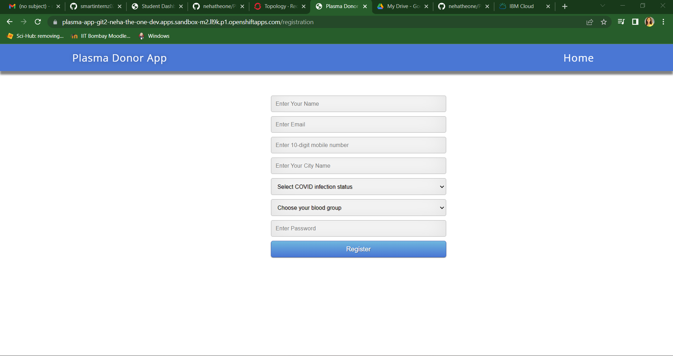

Login page:

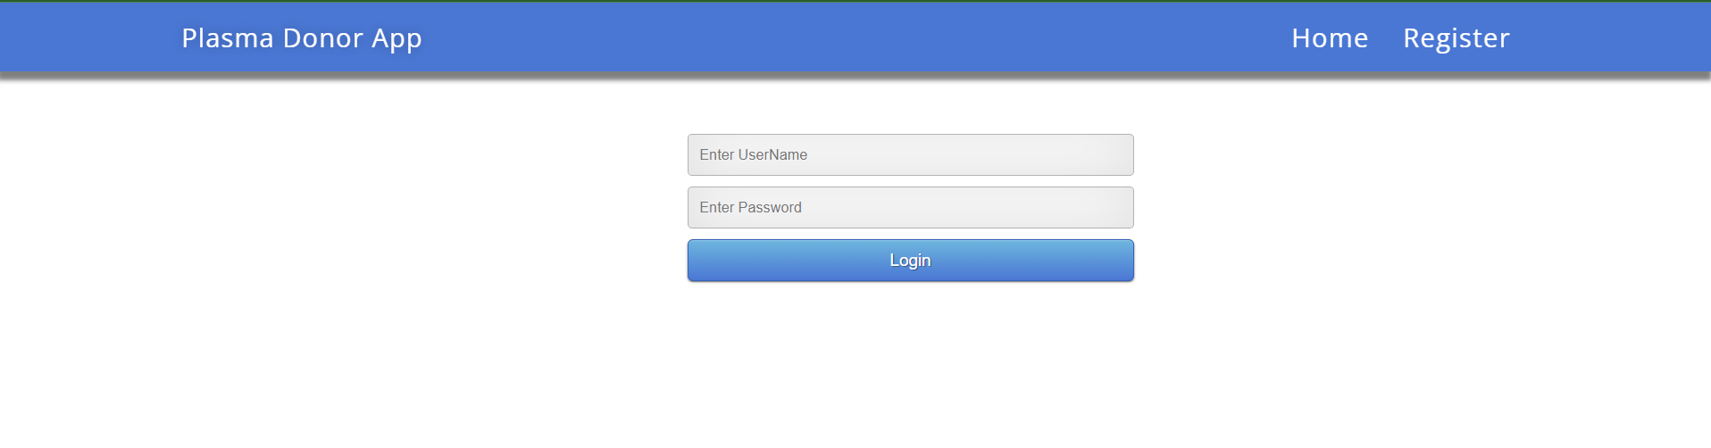

User interface after login:

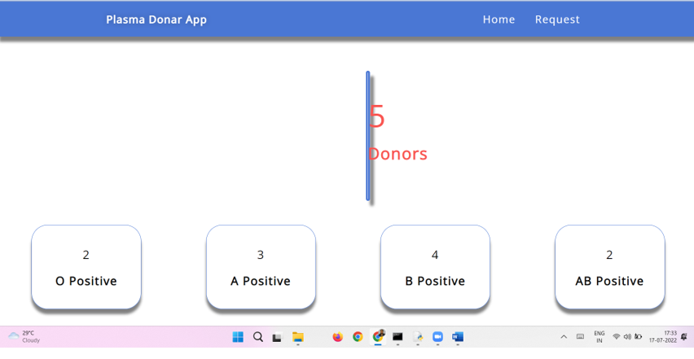

Code:

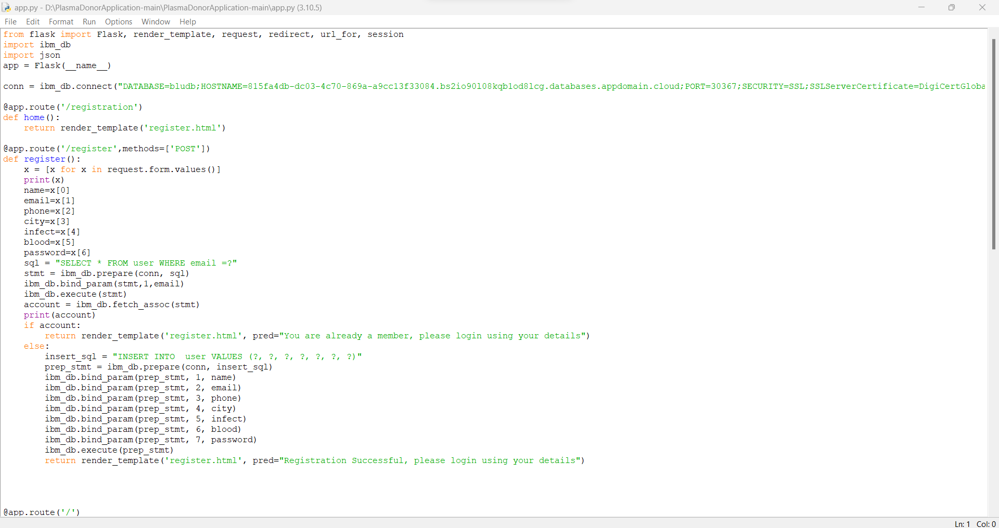

Deployment status

